AVF Database Migration

Knowledge Transfer Document

4/13/2018

[Type the company name]

Ajoy Sinha

AVF Setup Document

Document identifier:

Location:

Editor:

Contributors:

Abstract:

Status:

Table of Contents

1 Introduction 3

1.1 Terminology 3

2 Basic Setup 4

2.1 Network Configuration 4

2.2 AWS Schema Conversion Tool Installation 4

2.3 Connectivity Test 4

3 Convert Schema using SCT (Schema Conversion Tool) 5

3.1 Create Project 5

3.2 Connect to Source Database 5

3.3 Connect to Destination Database 5

3.4 Create Mapping Rule 5

3.5 Convert Objects 5

4 Port data using Database Migration Service (DMS) 6

4.1 Create Replication Instance 6

4.2 Connect to Source Database 6

4.3 Connect to Destination Database 6

4.4 Create Rule 6

4.5 Create Task 6

4.6 Migrate Data 6

4.7 Check Status 6

5 Execute Post Migration Script 7

5.1 Execute Quartz Scheduler Script 7

5.2 Execute ID default Value setup Script 7

6 References 8

6.1 Normative 8

Appendix A. 9

# Introduction

## Terminology

# Basic Setup

## Network Configuration

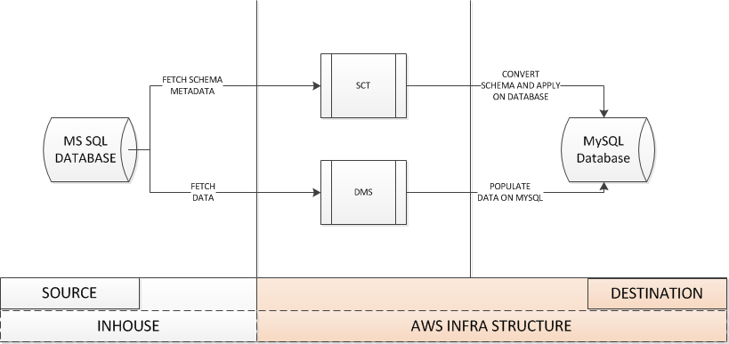

1. AWS Instance needs to be able to connect to MSSQL database instance and vice versa. We can test using telnet if connectivity has been established.

## AWS Schema Conversion Tool Installation

Schema Conversion Tool can be installed by following AWS documentation

<https://docs.aws.amazon.com/SchemaConversionTool/latest/userguide/CHAP_SchemaConversionTool.Installing.html#CHAP_SchemaConversionTool.Installing.Procedure>

This will download a installer depend on OS. That needs to be installed following installation process specific to OS

After successful installation a page like this will be opened

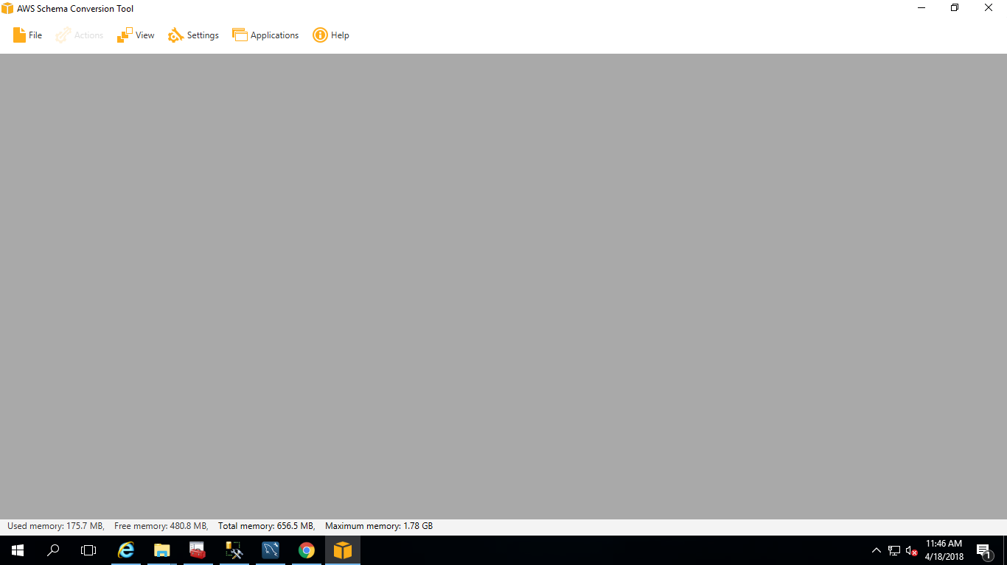

## Connectivity Test

We will create two connectivity from SCT.

1. Connect to SOURCE
2. Connect to DESTINATION

To this Connectivity we need to create a project first

### Create Project

1. Open SCT
2. Click File > New Project
3. Give Project Name
4. Give Location
5. Select OLTP
6. Source Database Engine : SQL Server
7. Target Database Engine : Amazon RDS for MySQL

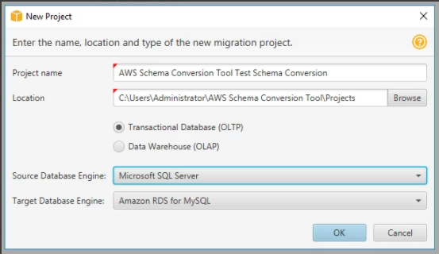

### Connect to Source Database

1. Click on Connect to Microsoft SQL Server
2. Enter Server name ( This is In-house SQL Server and this Server should be accessible from AWS)
3. Enter Server Port (This port should be opened in Firewall as well as this should be accessible from AWS)
4. Enter User Name and Password of SQL Server
5. Click Test Connection, If  successful then press "OK"
6. If unsuccessful then check the Network (VCP , Security Group and Inbound / Outbound rules, ACL in AWS) and connection parameters (Server name , Port, userid, password)

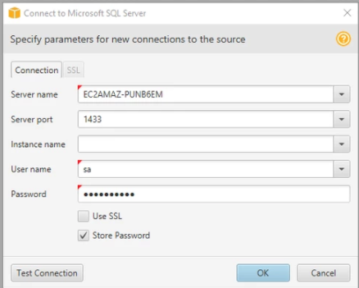

If Source connected properly then following things will be displayed in SCT left window

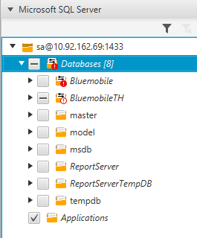

### Connect to Destination Database

1. Click on Connect to Amazon RDS for MySQL
2. Enter Server name ( RDS MySQL Server Instance Name)
3. Enter Server Port (This port should be opened in Windows Firewall as well as in Security Group)
4. Enter User Name and Password
5. Click Test Connection, If  successful then press "OK"
6. If unsuccessful then check the Network (VCP , Security Group and Inbound / Outbound rules, ACL in AWS) and connection parameters (Server name , Port, userid, password)

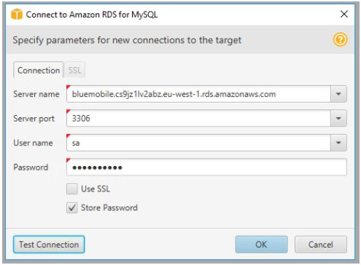

If Source connected properly then following things will be displayed in SCT left window

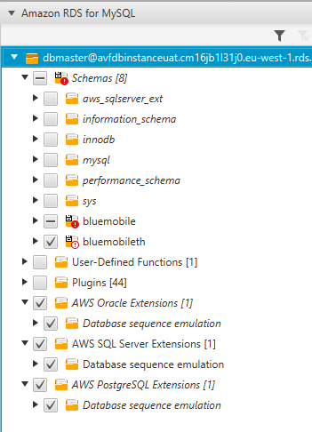

### Create Mapping Rule

1. Click on Settnigs > Mapping rule
2. Set rules as below

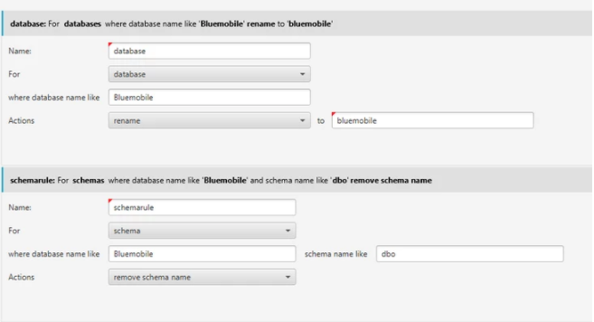

### Convert Objects

1. Select database [ Bluemobile ] in SQL Server
2. Expand Bluemobile
3. Select only Procedures (As Below)
4. Right Click > Convert Schema

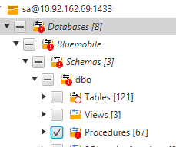

1. On Successful Conversion you will find as below

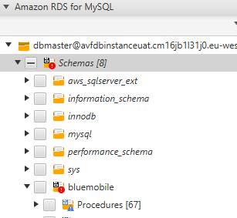

1. Uncheck Procedures
2. Select only Tables
3. Right Click > Convert Schema
4. On Successful Conversion check objects on right hand side
5. Uncheck Tables
6. Select only Views
7. Right Click > Convert Schema
8. On Successful Conversion check objects on right hand side
9. Uncheck Views
10. Select only Functions
11. Right Click > Convert Schema
12. On Successful Conversion check objects on right hand side

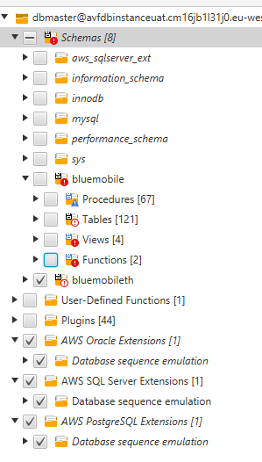

1. After Convert Schema go into right hand side to your SCT Panel

Right Click > Apply to database

Repeat above step for All Procedure / Tables / Views / Functions and Apply to database. This will update Schema in MySQL Database

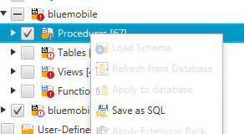

# Port data using Database Migration Service (DMS)

## Create Replication Instance

1. Access Database  Migration Service
2. Create Replication Instance as Below

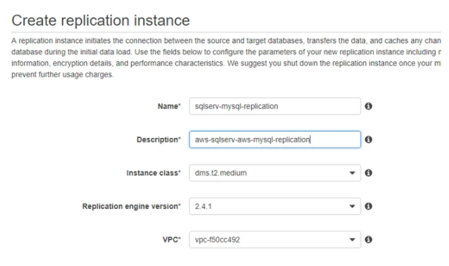

Details

Name: Provide a suitable name

Description: Provide a Suitable Description

Instance Class: Please discuss with Network Team for Instance Class. Cause this incur COST. Hence Management team need to confirm Instance Class

Replication Engine Version: Keep it default

VPC: Discuss with Network Team Which VPC we should use

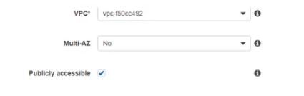

Make Multi AZ : NO

Publicly Accessible : Yes

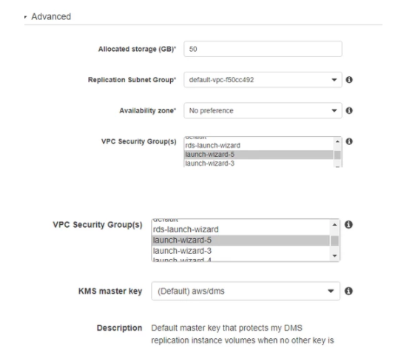

In Advance Section

Allocate Storage : Keep the Storage depend on Source Database Size. [The required size of this instance varies depending on the amount of data you need to migrate] For AVF better put a size around 300 GB [As current Database Size is 200 GB]

Replication Subnet Group / Availability Zone / VPC Security Group : Find these values from Network Team

KMS Master Key: Auto populate

Create Replication Instance and save it

## Connect to Source Database

* Create Endpoints  as Source as mention below

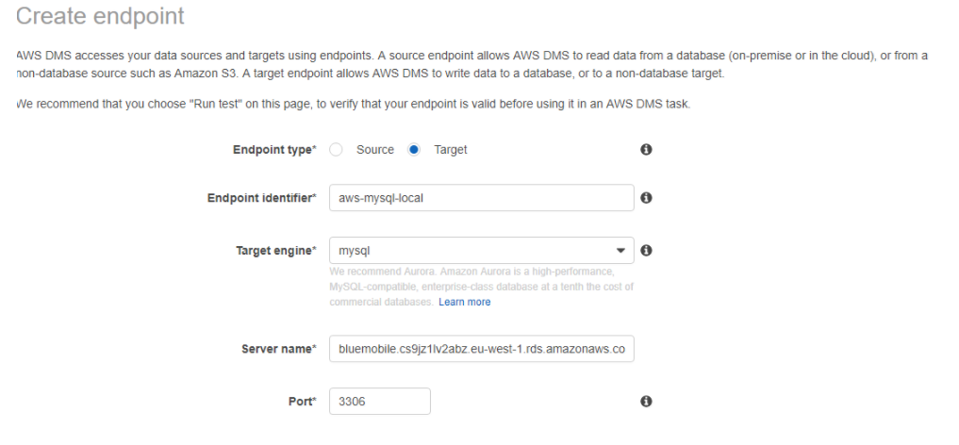

Select Followings

Endpoint Type: Source

Endpoint Identifier: Provide a Description and Name to it

Target Engine: MSSQL (Microsoft SQL Server)

Server Name: Provide IP or Name Identifier of Database Server

[Please note: Network Team should create / establish connectivity between AWS and In-house Database before this exercise]

Port: Provide Database Port

[Please note: Network Team should create / establish connectivity between AWS and In-house Database before this exercise]

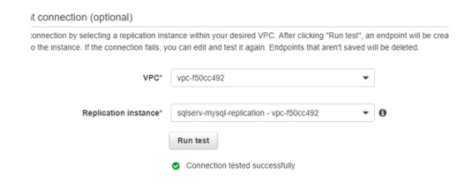

Select Followings

VPC: Discuss with Network Team what VPC should use

Replication Instance: This will be the name of Replication Instance which has been created earlier step.

Click on “Run test”

If connection has been established, then “Connection tested successfully” will be displayed

If any error occurred, then we need to work with Network team to establish connectivity.

## Connect to Destination Database

* Create Endpoints  as Source as mention below



Select Followings

Endpoint Type: Target

Endpoint Identifier: Provide a Description and Name to it

Target Engine: MSSQL (Microsoft SQL Server)

Server Name: Provide IP or Name Identifier of Database Server

[Please note: Network Team should create / establish connectivity between AWS and In-house Database before this exercise]

Port: Provide Database Port

[Please note: Network Team should create / establish connectivity between AWS and In-house Database before this exercise]

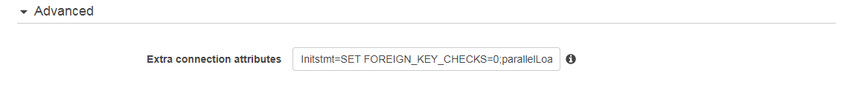

Select Followings

Extra connection attribute:

Initstmt=SET FOREIGN_KEY_CHECKS=0;parallelLoadThreads=1



Select Followings

VPC: Discuss with Network Team what VPC should use

Replication Instance: This will be the name of Replication Instance which has been created earlier step.

Click on “Run test”

If connection has been established, then “Connection tested successfully” will be displayed

If any error occurred, then we need to work with Network team to establish connectivity.

## Create Task

Click on Task > Create Task

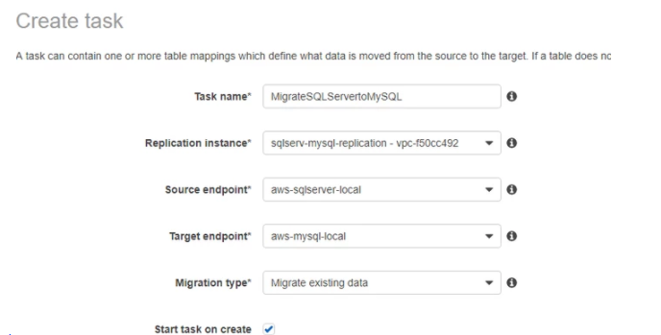

Select Followings

Task Name: Put Proper Task Name

Replication Instance: Select Replication Instance

Source endpoint: Select Source Endpoint

Target endpoint: Select Target Endpoint

Migration Type: Migrate existing data

Start task on create: uncheck

## Create Rule

Add following rules

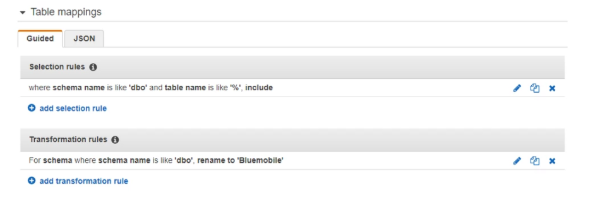

Do same for BluemobileTH database also

## Run Task and Migrate Data

* Click on task > Select Task using check box > Click on Start / Resume

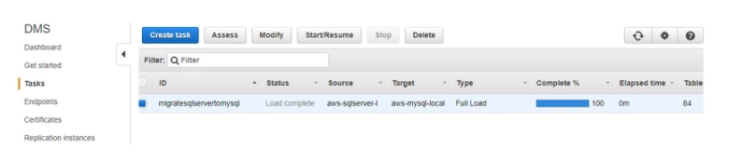

## Check Status

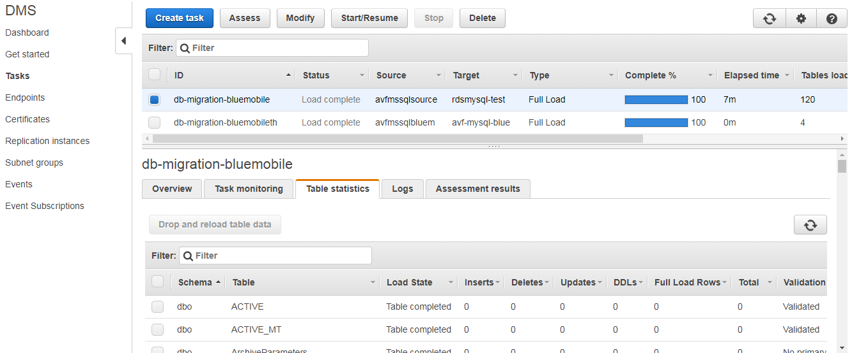

# Execute Post Migration Script

## Execute Quartz Scheduler Script

Execute following Scripts

For Quartz Upgrade

## 

## Execute ID default Value setup Script

For ID setup Upgrade



# References

## Normative